Practical Tech Tips for ESOL Teachers
Chris Spackman
2021 May 4

Practical Tech Tips for ESOL Teachers

Introduction
Today we will talk about some practical tech tips that will probably, hopefully, most likely, make you more productive.
Chris Spackman’s
first computers were a Magnavox Odyssey and a Commodore 64
Keyboard shortcuts
save you time and protect your wrists
Google Translate
is much cheaper than a professional translator or interpreter
Documents & formatting
impact educational outcomes
Accessibility
is also for English Learners (and their families)

About Me
ESOL Experience
- Worked in English as a Foreign Language (EFL) in Japan for 13 years
- MA TESOL from, and teaching license work done at, Ohio Dominican University
- ESOL teacher / coordinator at The Graham Family of Schools since 2010
- Instructor at Columbus State Community College Language Institute since 2016

About Me (continued)
Tech Experience
- Using computer since the late 1970s / early 1980s
- Experience with MS Windows 3.1+, Mac OSX, Linux
- Linux user since 1998. Currently use Gentoo Linux (home) and Xubuntu Linux (work).
- Create and manage several websites, from the 1990s to today

Conventions

— show keyboard keys, with the letter(s) or graphic from the key.
The key is shown uppercase (the shape on the keyboard), but should be entered lowercase (no , unless indicated).

— means “click” (press and release) the “Left Mouse Button”.

— shows menu entries that you would navigate with your mouse or with keyboard shortcuts.

— indicate folder paths and files. For example,

Keyboard Shortcuts

KB Shortcuts
Easiest way to do more, faster, with less damage to your wrists (avoid the mouse).
These shortcuts are great when editing documents.
/ :
moves left or right a word at a time.
/ :
moves up or down a paragraph at a time.
/ :
selects left or right a character at a time.
/ :
selects up or down a line at a time.
These shortcuts: fast and free you from the mouse.
Game changers when editing documents.

Keyboard Shortcuts (continued)
Put the previous shortcuts together for a paradigm shift!
/ :
selects left or right a word at a time.
/ :
selects up or down a paragraph at a time.
The selection is persistent (enough), so switch between and
(for example), to select a line and then a few more words.
Easily, quickly, and precisely, select regions of text to copy (), cut (), or delete (). Add to paste and do a lot of editing — without using the mouse at all.

Keyboard Shortcuts (continued)
Keyboard + mouse click shortcuts are also a thing. These are mostly for selecting files in a file manager or an “Open file” dialog.
:
selects several separate items. LibreOffice Writer will also let you select words ( + + on word) this way — great for quickly applying formatting to several words.
:
selects all the items between two items. Single left click the first normally, then press and then on the final item. Everything in between will also be selected, automagically.
- The first and last items are included in the selection.

Example:
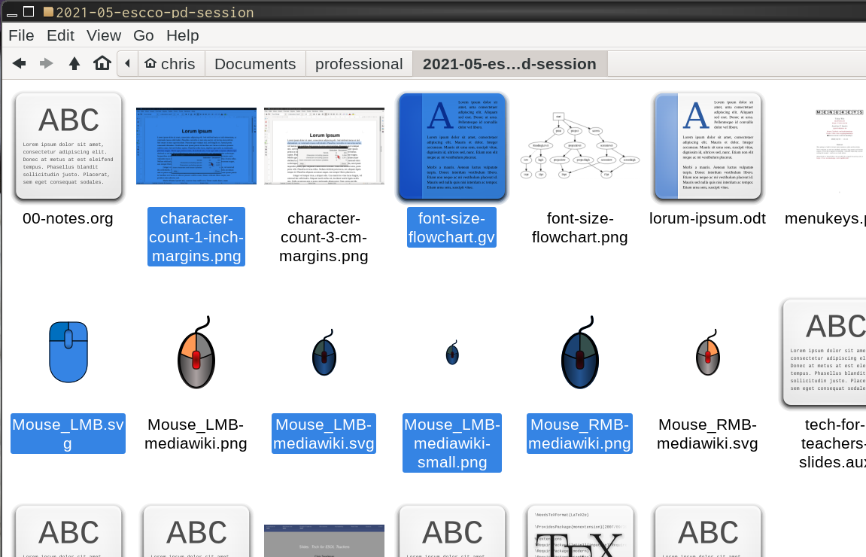

Example:
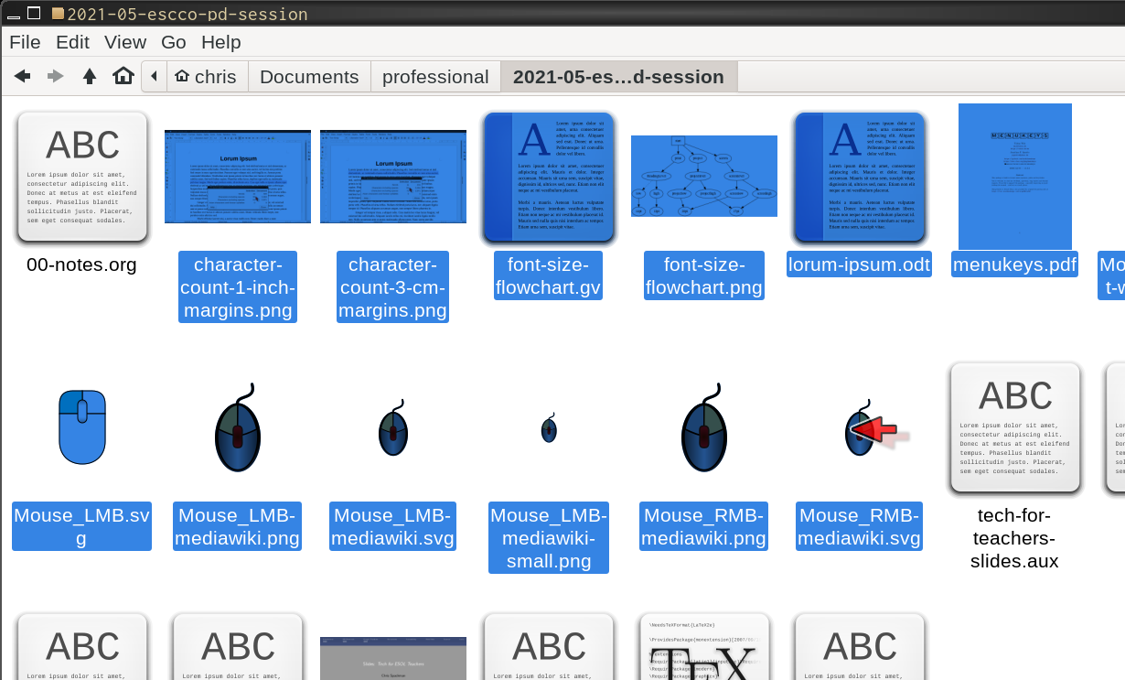

Google Translate

Google Translate
Web interface
is simple back-and-forth for shorter texts, directions, chatting, etc.
GDoc translation
will keep formatting, links, etc. No page limit?
File upload
will keep the formatting, links, etc. Will do about 30-ish pages.
Conversation
uses the microphone and speakers. Very helpful when typing is too slow.

Translating PDFs
Translating PDFs is not great, but not horrible. To translate, we convert the PDF to a Google Doc and then translate that.
Translating Google Docs always creates a new document.
- Upload PDF to Google Drive.
- Double click to view PDF.
- Click on “Open with Google Docs” at the top of the screen.
You might have “Open with …” and then a drop down choice of several apps. Choose “Google Docs”.
(continued on next slide)

Translating PDFs (continued)
- Fix the formatting. It will probably not be correct.
- Go to . Choose the language you want from the dropdown menu.
- Choose the name for the new document, if you want.
I don’t like “”, so usually remove that and put the language at the end: , for example. (“Es” for “Español”)
- Finally, click on “Translate” button. The translated document will open in a new window.
TIP: Sometimes it is easier and faster to copy text from a PDF and paste it into a new document. This does not work with all PDFs, however.

Translating Slides
Translating slides the easy way …
Unlike Google Documents, Google Slides does not have .
- Download your slides as from .
- Click on the “Documents” button at the top of Google Translate.
- Make sure the to and from languages are selected
- Upload the PPTX file (“Browse your computer”, select, then “Translate”).
(continued on next slide)

Translating Slides (continued)
- A translated version will appear. It has all the text from all the slides, but no slide formatting.
- If you are making a translated version, make a copy of your current slides.
- Copy and paste from the translated document into your slides.
If only two languages, then for most classroom use I prefer one set of slides with both the L1 and English.
TIP: Be aware of English in graphics. That won’t get translated. You will have to add translations for that by hand.

Translating Slides (the less easy way)
Sometimes, you need to go old school to translate.
- Download from .
- Open the plain text document and add some abbreviated notes to help after you translate. (Less important if you understand the language.) For example:
  - SS1 / ES1 — for “start slide 1” / “end slide 1”
  - HL1 — for “Heading level 1”
  - *word* — to show the word was bold
  - - text — to show the word text is part of a bullet list
- Click on the “Documents” button at the top of Google Translate.
(continued on next slide)

Translating Slides (continued)
- Make sure the to and from languages are selected
- Upload the plain text file (“Browse your computer”, select, then “Translate”).
- A translated version will appear. It has all the text from all the slides, but no slide formatting. Hopefully your abbreviated notes were not translated
- If you are making a translated version, make a copy of your current slides.
- Copy and paste from the translated document into your slides.
- Redo the formatting, using the abbreviated note you added.

Marked-Up Plain Text Example
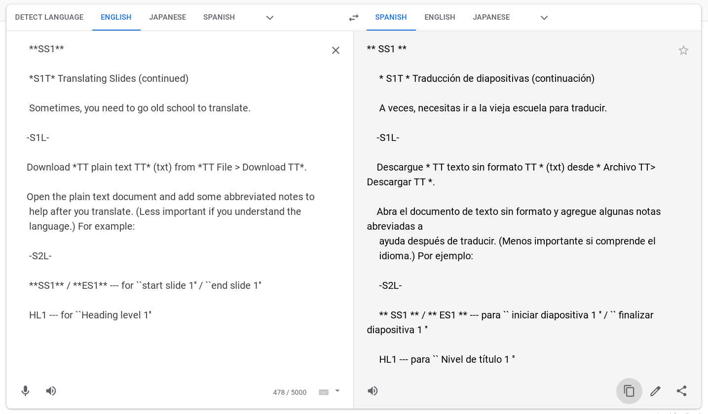
Check out my video on translating slides for more on how to do it with markup.

Documents & Formatting

Documents
Formatting can have a significant impact on student learning.
Margins
should be whatever is left over after you set font size and line length.
Line length
is about how many characters there are on one line of text. Materials for adult, fluent readers usually have about 60 to 90 characters per line. Materials for young readers have much shorter lines. For struggling readers, stay to the low end of the range for their age and level.
Fonts
need to be appropriate for the reader. Andika is a good font for students who may be confused by TNR-esque “a” and “g” letter shapes. “Dyslexic fonts” are NOT proven to be helpful (PDF).

Documents & Formatting (continued)
Font Sizes
Fonts have different base sizes. 12pt Times New Roman is smaller than 12pt Liberation Serif. If students need to , the font is too small.
- printed paper: 12 point for regular text for most students; at least 13 or 14 point for lower reading-level students.
- screen: at least 18 point for regular text for most students; 20 point or bigger for lower level students. Consider switching to landscape orientation.
- projected: generally at least 20pt or bigger.
- word wall: (vocab word card on your wall) generally at least 36pt or bigger.
Also beware laminated items and overhead lights.

Documents & Formatting (continued)
- Bonni Stachowiak’s “Teaching in Higher Ed” podcast has several episodes about design & clarity, materials creation, etc. Aimed at higher ed, but much is applicable to k-12 teaching as well.
- Gabriela Kleckova and Pavel Svejda have a great book, Creating Visually Effective Materials for English Learners about this.
- Robin Williams (not that one) has a great book about design, The Non-Designer’s Design Book. It is not for, or about, education, but the design principles apply to educational materials also.
These appear again in the section “Clarity” — there is a lot of overlap here, I admit.

Traditional Formatting: Small Fonts, Small Margins
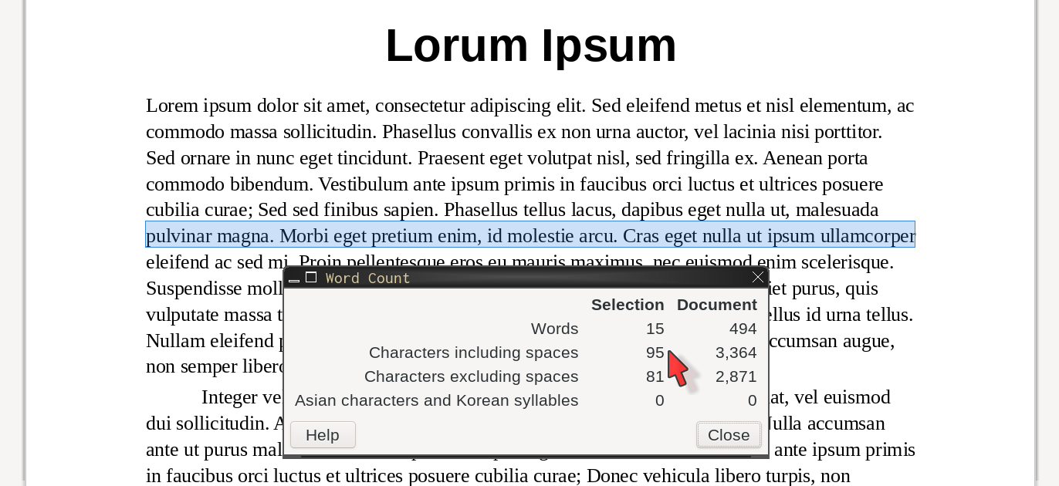
- 12-point font
- 1-inch (2.54cm) margin
- 100% line spacing (1.0)
- ~95 characters / line!
Paper or screen, this page can be difficult for learners to read.

Much Better: Bigger Font, More White Space
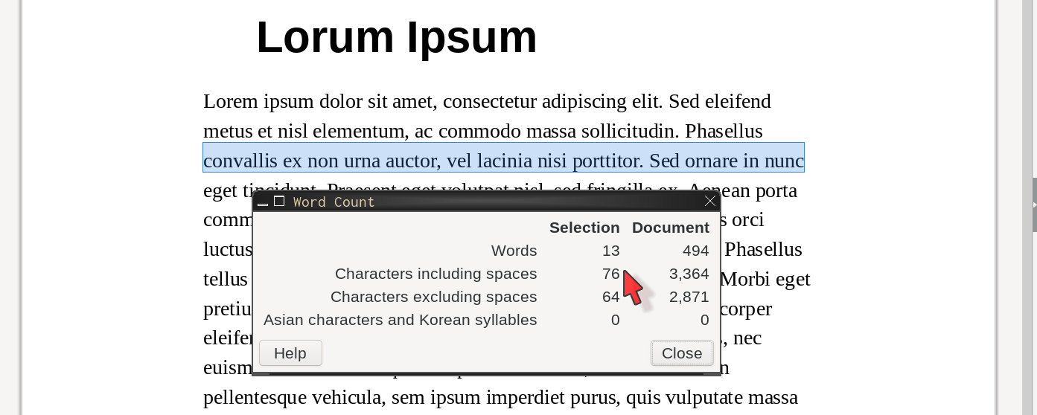
- 13-point font
- 1.57-in (4cm) margin
- 125% line spacing
- ~76 characters / line.
This page is much better. Content aside, for HS students, this will be easier to read.

Margin Notes: Start of an “Enhanced” Reading
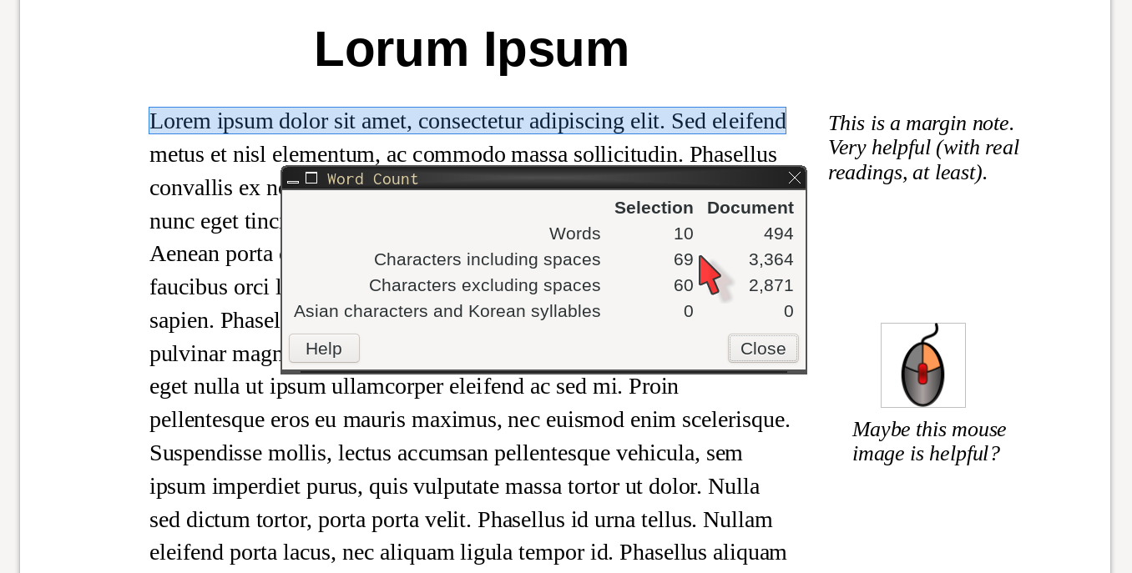
- 13-point font
- 2.17-in right margin
- 1-in left margin
- 125% line spacing
- ~69 characters / line.
Easy to read, plus helpful information in the margins; start of “enhanced” reading.
Add images, color, links to resources to maximize student understanding.

Creating Margin Notes
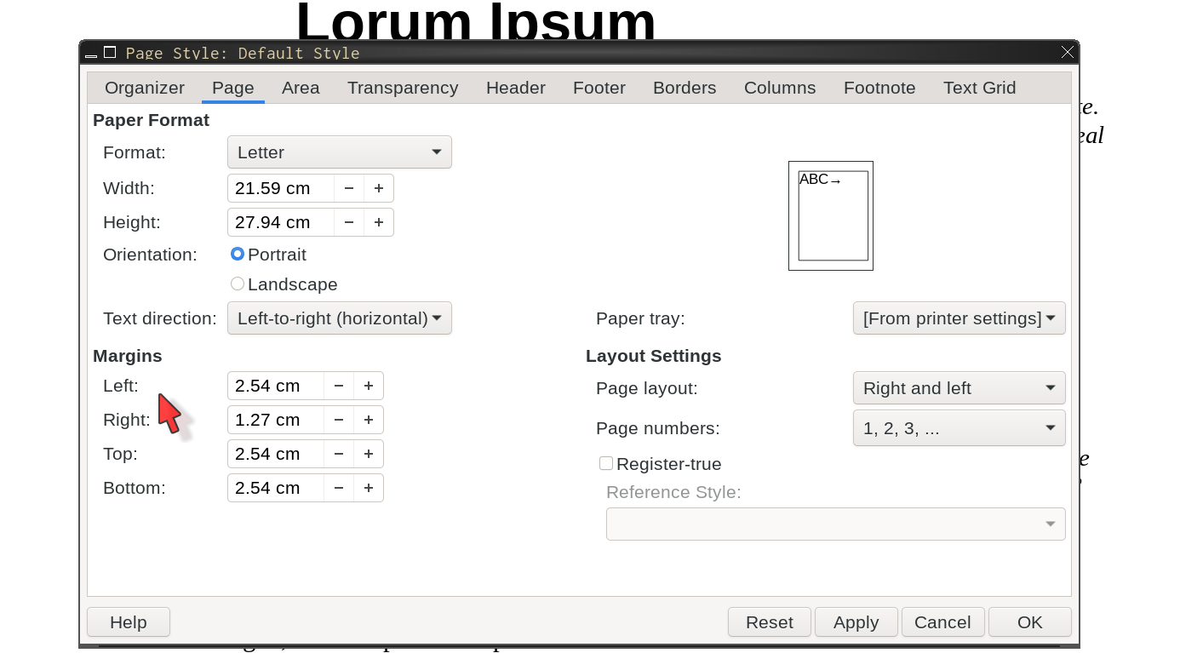
- Set page margins
  - left: 1-inch
  - right: 0.5-inch
This is for LibreOffice. Process will be similar for Google and MS Word.

Creating Margin Notes (step 2)
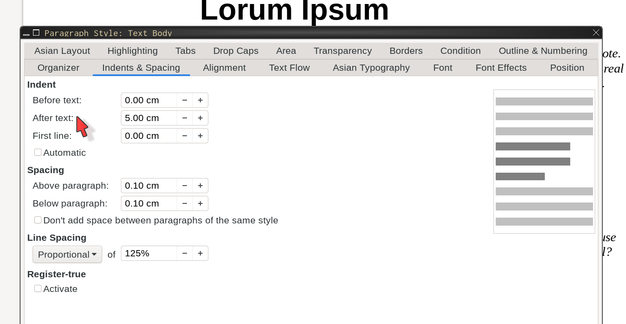
- Add space after text
  - then
  - After text: 1.5-in

Creating Margin Notes (step 3)
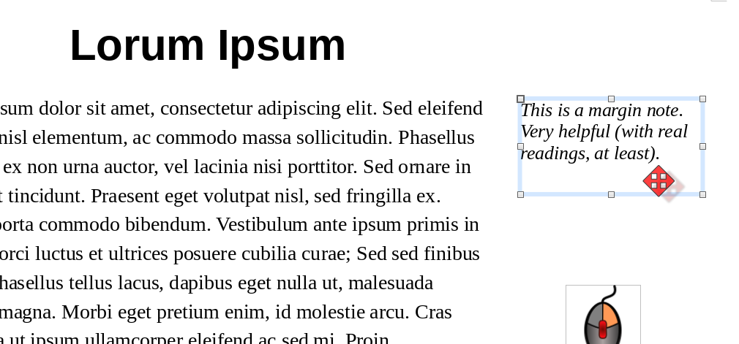
- Add text boxes
  - draw in margin
  - to edit
- Add images
  - choose file
  - put in margin
This is for LibreOffice. Check How to make an enhanced reading in Google Docs on Youtube if you use Google Docs.

Accessibility

Accessibility
Accessibility is also for English Learners and their families.
Subtitles
(in English or L1) are helpful for parents / guardians who may have trouble with English or are hard of hearing.
Page layout
should not be done with tables. Tables are great for data, but can confuse screen readers or the people using them.
Clarity
in worksheets, flyers, etc. can help with understanding.
See Creating Visually Effective Materials for English Learners by Gabriela Kleckova and Pavel Svejda for more information on formatting for understanding.

Accessibility (continued)
Subtitles / Captions
Subtitles (in English or L1) are helpful for parents / guardians who may have trouble with English or are hard of hearing. (And students, too!)
- Google YouTube and many other sites can automagically add subtitles to videos, for free. Not all sites allow you to edit or download the subtitles for free.
- Google recently added on-the-fly captions to the Google Chrome browser. Should work on any video played in the browser. Claims to translate, but didn’t work.
- Right now, https://www.Veed.io is the only site I’m aware of that will automagically translate subtitles for your video. It requires the Pro subscription, which is about $30 a month, if you pay monthly.

Accessibility (continued)
Page Layout
Page layout should not be done with tables. Tables are great for data, but can confuse screen readers or the people using them.
Good use of a table (data)
Period | Start | End
1st | 9:30 | 10:25
2nd | 10:30 | 11:25
3rd | 11:30 | 12:25
Bad use of a table (formatting)
Who does Juliet love? | Akiko
 | Marci
 | Romeo
 | Zulfa

Accessibility (continued)
Other layout tips
- Use paragraph styles for formatting headers, regular text, indented text, etc. Styles allow:
  - you to quickly make changes for the entire document;
  - screenreaders to understand the purpose of the paragraphs (important!);
  - your word processor to add links and a Table of Contents easily.
- Use “Tab Stops”[tabstops] to place text horizontally on the line. Tab Stops are probably the easiest way to avoid using tables for page layout.
Don’t use or the key (Tab Stops ).

Accessibility (continued)
Clarity
- Bonni Stachowiak’s “Teaching in Higher Ed” podcast has several episodes about design & clarity, materials creation, etc. Aimed at higher ed, but much is applicable to k-12 teaching as well.
- Gabriela Kleckova and Pavel Svejda have a great book, Creating Visually Effective Materials for English Learners about this.
- Gabriela Kleckova also has a useful blog post about “decluttering” at TESOL.org.
- Robin Williams (not that one) has a great book about design, The Non-Designer’s Design Book. It is not for, or about, education, but the design principles apply to educational materials also.

Accessibility (continued)
Clutter: Typos / Spacing / Etc.
Also be aware of typos or spacing that may confuse students. Real world example:
- Something like this was on a math test
Students were confused by “”. The lone ) and no space — students thought
- avoids confusion.
Use Tab Stops to tweak spacing between list numbers and the content.
(It was Question #3)

Links

Links
Creating Visually …
https://bookstore.tesol.org/creating-visually-effective-materials-for-english-learners-products-9781942799207.php
Creative Commons
https://creativecommons.org/licenses/by-sa/4.0/
CSCC LI
https://www.cscc.edu/community/language-institute/
Declutter
http://blog.tesol.org/tidying-up-your-elt-3-simple-ways-to-declutter-your-teaching/ (what, no httpS???)
Design Flaws
http://blog.tesol.org/teacher-made-materials-design-6-flaws-and-fixes/

Links (continued)
Dyslexic Fonts
https://eyeondesign.aiga.org/can-fonts-really-help-those-with-dyslexia/
Dyslexic Fonts
https://link.springer.com/content/pdf/10.1007%2Fs11881-016-0127-1.pdf (PDF)
Enhanced Readings
https://youtu.be/Muf3VNbmpnY (using Google Docs)
Gentoo Linux
https://www.gentoo.org
Google Translate
https://translate.google.com
LaTeX
https://latex-project.org
LibreOffice
https://www.libreoffice.org (Free/Libre/Open Source office suite)

Links (continued)
Mouse image
https://commons.wikimedia.org/wiki/File:Right_clicked_mouse.svg (CC-BY-SA license, 3.0 unported)
ODU
https://www.ohiodominican.edu
Resources from today
https://www.ChrisSpackman.com/Educator-Resources/PD/2021-05-04-ESCCO/
Teaching in …
https://teachinginhighered.com/episodes/ (Podcast)
TGFS
https://www.thegrahamfamilyofschools.org
Translating Slides
https://youtu.be/8hB8rifIisc
Veed.io
https://www.Veed.io (for translating subtitles)
Xubuntu
https://xubuntu.org

Thanks

Thanks
Thanks to my colleagues from
- The Charles School, and
- The Language Institute at Columbus State Community College
for suggestions and feedback on, and proofreading of, the content of this PD and these slides.
Of course, all mistakes are my own, including the ones in this document.

Copyleft

Copyleft
These slides were created on GNU/Linux (Gentoo Distribution) with Free / Open Source Software (mostly Emacs and LaTeX).
This document is copyright Chris Spackman.
These slides are licensed under a Creative Commons Attribution-ShareAlike 4.0 International License
Please see ChrisSpackman.com for editable versions of resources from our PD today.

